Hidden Layers in Artificial Neural Networks (ANNs)

**1. Definition of a Hidden Layer:**

* A hidden layer is an intermediate layer between the input and output layers in an artificial neural network.
* It processes the input data by applying weights, biases, and activation functions before passing it to the next layer.
* Helps in feature extraction and complex pattern recognition.

A hidden layer in a neural network is a layer of artificial neurons that processes input data and produces output. Hidden layers are located between the input and output layers of a neural network.

**Explanation**

Hidden: Hidden layers are not directly exposed to the input or output data.

Neurons: The nodes in hidden layers are called neurons.

Nonlinearity: Hidden layers introduce nonlinearity into the model, allowing neural networks to learn complex patterns.

Deep learning: Neural networks with multiple hidden layers are called deep learning models.

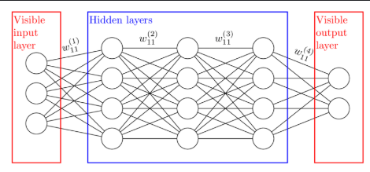

**2.Types of Hidden Layers:**

#### ****A. Fully Connected (Dense) Layer****

* Each neuron is connected to every neuron in the previous and next layers.
* Used in Multi-Layer Perceptrons (MLP) and Feedforward Neural Networks (FNN).
* Example: Used for structured data classification and regression tasks.
* Activation Functions: **ReLU, Sigmoid, Tanh**.

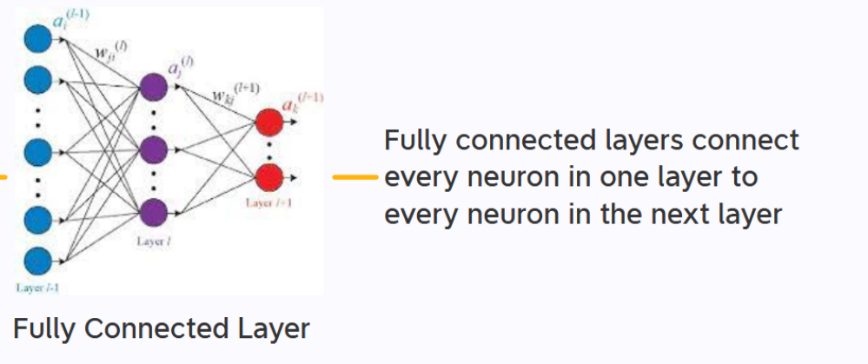

🔹 **Working:**

* Performs matrix multiplication with weights and applies an activation function.
* Helps in learning complex patterns in data.

🔹 **Common Activation Functions:**

* **ReLU (Rectified Linear Unit):** Handles vanishing gradient problem.
* **Sigmoid:** Used in binary classification.
* **Tanh:** Used when data is centered around zero.

🔹 **Applications:**

* Image classification
* Regression tasks
* Feature extraction in deep learning

#### ****B. Convolutional Layer (Conv Layer)****

* Applies convolution operation using small filters (kernels) to extract spatial features from input data.
* Used in Convolutional Neural Networks (CNNs) for image processing.
* Example: Image classification, object detection.

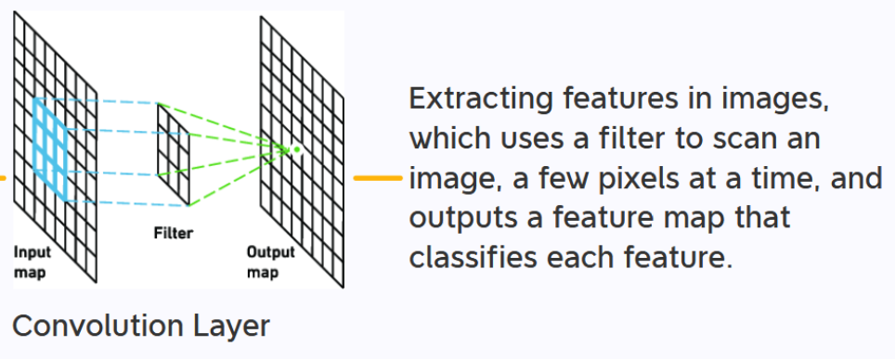

🔹 **Working:**

* Uses small filters (e.g., 3×3, 5×5) that slide over the input.
* Detects edges, textures, and objects.

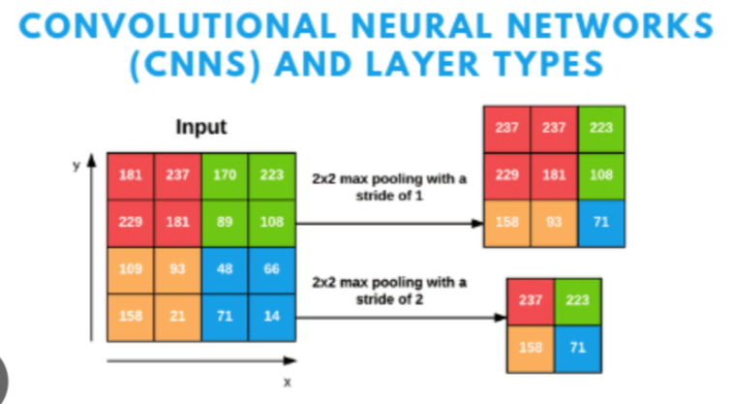

🔹 **Key Parameters:**

* **Filter Size (Kernel):** Determines the receptive field.
* **Stride:** Controls how much the filter moves.
* **Padding:** Adds extra space around the input to maintain dimensions.

🔹 **Applications:**

* Object detection (YOLO, SSD)
* Image recognition (Face recognition, Medical imaging)

#### ****C. Pooling Layer****

* Reduces the size of the feature maps and computational complexity.
* Types:
  + **Max Pooling**: Retains the maximum value from a window.
  + **Average Pooling**: Takes the average of values in a region.
* Used in CNNs for downsampling.

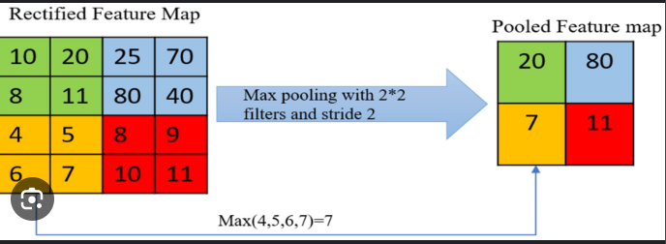

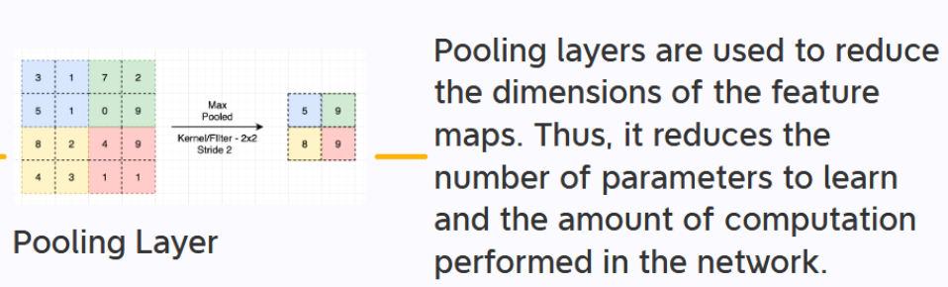

🔹 **Types:**

* **Max Pooling:** Selects the highest value in a region.
* **Average Pooling:** Takes the average of values in a region.

🔹 **Purpose:**

* Reduces computation and prevents overfitting.
* Helps in making networks translation invariant.

🔹 **Applications:**

* Reducing computational cost in deep learning models.

#### ****D. Recurrent Layer (RNN Layer)****

* Stores past information using feedback connections to process sequential data.
* Used in Recurrent Neural Networks (RNNs) and their variants:
  + **LSTM (Long Short-Term Memory)**: Solves vanishing gradient problems.
  + **GRU (Gated Recurrent Unit)**: A simplified version of LSTM.
* Example: Time series forecasting, speech recognition.

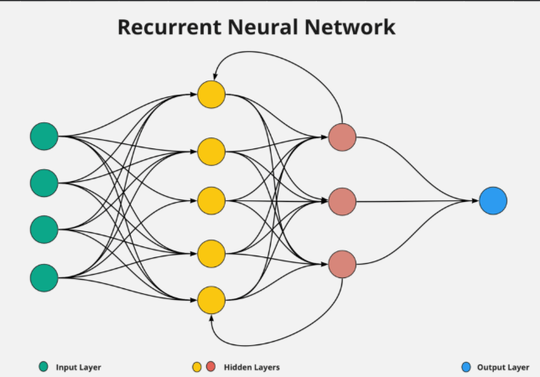

🔹 **Working:**

* Maintains a hidden state that carries information over time steps.
* Can process variable-length sequences.

🔹 **Types:**

* **Simple RNN:** Basic form of recurrence, but suffers from vanishing gradients.
* **LSTM (Long Short-Term Memory):** Uses gates (input, forget, output) to handle long dependencies.
* **GRU (Gated Recurrent Unit):** A simplified version of LSTM with fewer parameters.

🔹 **Applications:**

* Time series forecasting
* Speech recognition (Google Assistant, Siri)
* Language modeling (Chatbots, NLP)

#### ****E. Normalization Layers****

* Used to stabilize training and improve convergence.
* Types:
  + **Batch Normalization**: Normalizes activations across a batch.
  + **Layer Normalization**: Normalizes activations across neurons.
* Example: Used in deep neural networks for faster training.

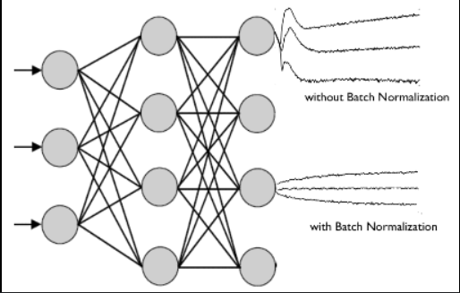

🔹 **Applications:**

* Deep networks with large datasets.
* Faster convergence in CNNs and RNNs.

#### ****F. Dropout Layer****

* Randomly drops neurons during training to prevent overfitting.
* Example: Used in deep learning models to improve generalization.

🔹 **Working:**

* Prevents overfitting by ensuring neurons do not depend too much on one feature.
* Common dropout rates: **0.2 to 0.5** (20% to 50% neurons dropped).

🔹 **Applications:**

* Deep neural networks to improve generalization.

#### ****G. Attention & Transformer Layers****

* Focuses on important parts of the input by assigning attention scores.
* Used in Natural Language Processing (NLP).
* Example: BERT, GPT models.

🔹 **Working:**

* Uses **Self-Attention Mechanism** to weigh input elements based on their importance.

🔹 **Applications:**

* Machine translation (Google Translate)
* Chatbots (ChatGPT, Bard)
* Text summarization

**3. Importance of Hidden Layers**

* Perform non-linear transformations to extract complex patterns.
* Help in learning hierarchical representations of data.
* Improve accuracy and generalization of deep learning models.

**4. Number of Hidden Layers &Neurons**

* **Single Hidden Layer**: Suitable for simple problems.
* **Multiple Hidden Layers (Deep Learning)**: Required for complex tasks like image and speech recognition.
* **Number of Neurons**: Selected based on trial-and-error or hyperparameter tuning.

**5.Activation Functions in Hidden Layers**

* **ReLU (Rectified Linear Unit)**: Most commonly used due to fast convergence.
* **Sigmoid**: Used for probabilistic outputs but suffers from vanishing gradients.
* **Tanh**: Better than sigmoid but still has gradient issues.
* **Leaky ReLU**: Fixes the zero gradient problem of ReLU.

**6.How Hidden Layers Work**

1. Take input values from the previous layer.
2. Apply weights and biases.
3. Pass through an activation function.
4. Forward the result to the next layer.